**CHAPTER THREE**

**METHODOLOGY AND DESIGN**

3.1 **INTRODUCTION**

This is basically a presentation of end results of systems analysis (of the existing system) and design (of the new system) processes stating clearly the method and tools employed by the researcher. Method of data collection during this research includes studying the organizational principle and underlying rules. Object-Oriented Methodology is going to be used in this project considering the fact that today’s systems (programming languages) are majorly object oriented.

3.2 **METHOD OF DATA COLLECTION**

In executing any system, one has to have an insight of what is happening, it is important that information and fact about the existing system is gathered. In executing this research, two methods were employed

1. Observation method.
2. Documentation.

3.2.1 **OBSERVATION METHOD**

This method was employed in gathering information/data for this research by seeing the way in which the manual system was carried out. The glaring issues with the existing system were detected by careful observation.

3.2.2 **DOCUMENTATION**

Documentation method is a secondary method of data collection. This method involves the use of journals, handbooks, past projects and newspapers. This method of data collection was used because it serves as a basis of reference to existing research work. This includes internet which is a method of data collection, the web was used in sourcing for information such as Software Tutorial on Troubleshooting Micro-computers. Example [www.wikipedia.com](http://www.wikipedia.com) , [www.techsoup.org](http://www.techsoup.org), [www.sbs.ac.in](http://www.sbs.ac.in) etc.

**3.3 SYSTEM MODELING**

Systems modeling or system modeling is the interdisciplinary study of the use of [models](https://en.wikipedia.org/wiki/Scientific_modeling) to conceptualize and construct [systems](https://en.wikipedia.org/wiki/System) in [business](https://en.wikipedia.org/wiki/Business) and [IT development](https://en.wikipedia.org/wiki/Information_technology). In this research work, a Unified Modelling Language (UML) is used.

**UML** (Unified Modeling Language):

The Unified Modeling Language is a general-purpose, development, modeling language in the field of software engineering that is intended to provide a standard way to visualize the design of a system.

**3.3.1 Use Case Diagram**

The purpose of Use Case Diagram is to present a graphical overview of the functionality provided by a system in terms of actors, their goals (represented as use cases), and any dependencies between those use cases.

**System**

**Admin.**

**Technical Users.**

**Users.**

**Fig 3.1 System Use Case Diagram**

**3.3.2 Class Diagram**

Class diagrams are visual representations of the static structure and composition of a particular system using the conventions set by the Unified Modeling Language (UML). Out of all the UML diagrams types, it is one of the most used ones. Using class diagrams, it is easier to describe all the classes, packages, and interfaces that constitute a system and how these components are interrelated. The top partition contains the name of the class; the middle part contains the class’s attributes while the bottom 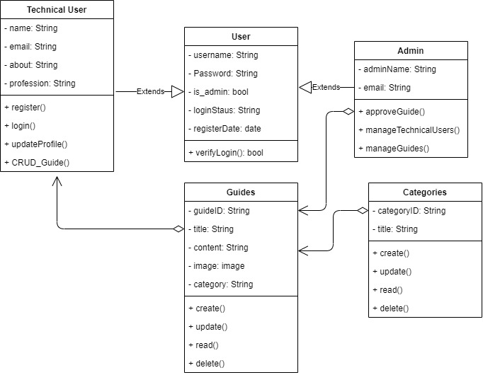partition shows the possible operations that are associated with the class.

**Fig 3.2 System Class Diagram**

# 3.3.3 Activity Diagram

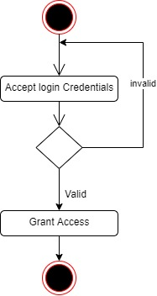

**Fig 3.3 Login Activity Diagram**

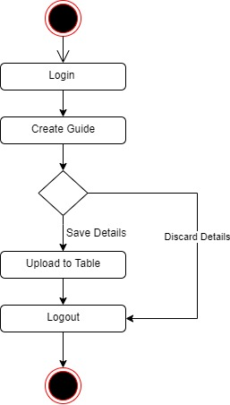

**Fig 3.4 Upload Tutorial Guide Activity Diagram**

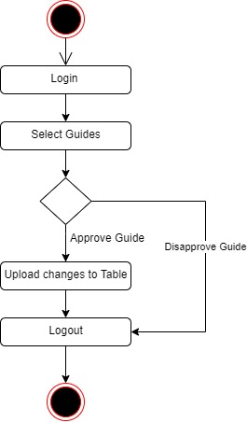

Fig 3.5 Admin Tutorial Approval Activity Diagram

# 3.4 DATABASE DESIGN

Input specification is the logical presentation of how data is stored in the computer’s memory. The input specifications used in this project work are presented below:

**Table 3.1 User Login Table input specification table**

|  |  |  |  |
| --- | --- | --- | --- |
| **FIELD NAME** | **DATA TYPE** | **LENGTH** | **DESCRIPTION** |
| Username | String | 150 | Username for login (case sensitive) |
| Password | String | 150 | Access Code (case sensitive) |
| is_staff | Boolean | 1 | To differentiate technical user from the admin |
| User_id | String | 64 | A unique string for identifying users |

**Primary key:** User_id

TABLE **3.2: User Profile Table input specification table**

|  |  |  |  |
| --- | --- | --- | --- |
| **FIELD NAME** | **DATA TYPE** | **FIELD SIZE** | **DESCRIPTION** |
| User | int | 10 | Foreign key to the user table |
| Profession | String | 35 | User profession information |
| About | String | 8 | User about information |
| Picture | image | 500 | Profile picture |
| Profile_id | String | 64 | Unique string for each user profile |

**Primary key:** Profile_id

**TABLE 3.3: Tutorial Guide Input Specification Table**

|  |  |  |  |
| --- | --- | --- | --- |
| **Field NAME** | **DATA TYPE** | **FIELD SIZE** | **DESCRIPTION** |
| Title | String | 200 | Guide title |
| Body | String | 500 | Content of the tutorials |
| Guide_id | String | 64 | Unique string for each guide |
| Slug | String | 200 | To enhance search engine optimization |
| Image | String | - | To describe the tutorial |
| Approval | Boolean | 1 | O’ Level Result |
| User | String |  | Foreign key to user profile |

**PRIMARY KEY:** Guide Id

**TABLE 3.4: Tutorials Category Input Specification Table**

|  |  |  |  |
| --- | --- | --- | --- |
| **Field NAME** | **DATA TYPE** | **FIELD SIZE** | **DESCRIPTION** |
| Title | String | 200 | Guide title |
| Slug | String | 500 | To enhance search engine optimization |
| Category_id | String | 64 | Unique string for each guide |

**PRIMARY KEY:** Category_id

# 3.5 OUTPUT DESIGN

This declares and show the result obtained from the input specified. The output product by the automated system depends on the input. Below is the output specification.

**Table 3.5 User Login Table**

|  |  |  |  |
| --- | --- | --- | --- |
| **Username** | **Password** | **Is_Staff** | **User_id** |
| XXXXXXX | XXXXXXX | XXXXXXX | XXXXXXX |
| XXXXXXX | XXXXXXX | XXXXXXX | XXXXXXX |
| XXXXXXX | XXXXXXX | XXXXXXX | XXXXXXX |
| XXXXXXX | XXXXXXX | XXXXXXX | XXXXXXX |

**Table 3.6 User Profile Table**

|  |  |  |  |  |
| --- | --- | --- | --- | --- |
| **Profile_id** | **Profession** | **About** | **Picture** | **User** |
| 99999 | XXXXX | XXXXXX | XXXXX | XXXXX |
| 99999 | XXXXX | XXXXXX | XXXXX | XXXXX |
| 99999 | XXXXX | XXXXXX | XXXXX | XXXXX |
| 99999 | XXXXX | XXXXXX | XXXXX | XXXXX |

|  |  |  |  |  |  |  |
| --- | --- | --- | --- | --- | --- | --- |
| **Guide_id** | **Title** | **Body** | **Slug** | **Image** | **Approval** | **User** |
| 9999 | XXXXXX | XXXXXX | XXXXX | XXXXX | XXXXX | XXXXX |
| 9999 | XXXXXX | XXXXXX | XXXXX | XXXXX | XXXXX | XXXXX |
| 9999 | XXXXXX | XXXXXX | XXXXX | XXXXX | XXXXX | XXXXX |
| 9999 | XXXXXX | XXXXXX | XXXXX | XXXXX | XXXXX | XXXXX |

**Table 3.7 Tutorial Guide Table**

**3.6 INPUT AND USER INTERFACE DESIGN**

This displays the pictorial representation of the system interface, the interface is going to be designed in a way that it will be user friendly, responsive and attractive. It will also be well secured such that login will be required to access some level of contents. The designs are aided by a mid-fidelity wireframing tool called Draw.io

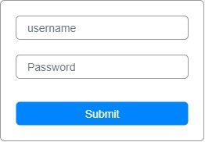

**Figure 3.6.1 User Login Page**

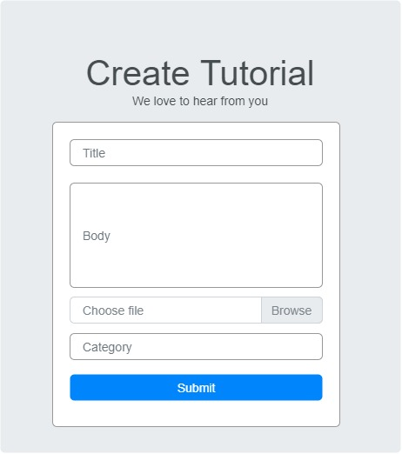

**Figure 3.6.2 Create Tutorial Guide**

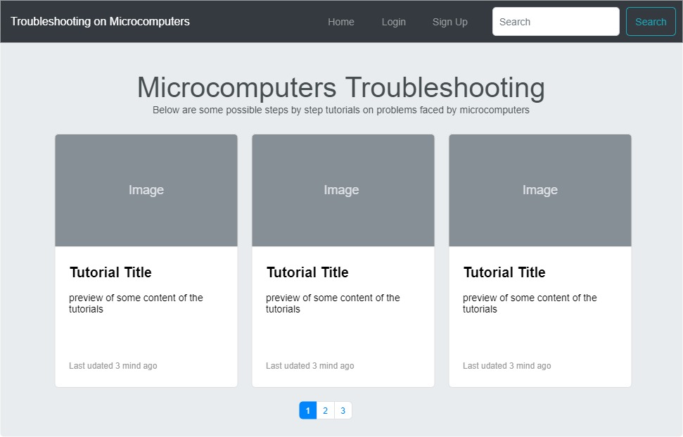

**Figure 3.6.3 Create Tutorial Guide**

**3.7 SYSTEM REQUIREMENT**

All software system developed has a predetermined system requirement on which it has been designed to operate on for maximum performance. However, the system requirements are the minimum hardware and software required for a smooth operation of the system that is designed.

# 3.7.1 The Hardware Requirement

System Hardware Requirement;

1. Minimum of Intel Dual core processor.
2. Minimum of 1 GB of RAM (Random Access Memory).
3. Minimum of 250GB HDD (Hard Disk Drive).

# 3.7.2 Software Requirement

Software Requirement;

1. At least window 7 OS.
2. Browsers includes: Chrome, Firefox.
3. Python installation
4. Vs Code installation

**3.8 CHOICE OF PROGRAMMING LANGUAGE**

Various types of programming language exist that could have been used in writing this tutorial application but the choices of programming languages used involve HTML5, CSS3, JavaScript, Python (Django) and SQLite. The reasons for choosing these programming languages is that it is a web base applications and require web programming language and are as follows:

a) HTML is the bedrock of Web Applications as it is the skeletal framework of a webpage. HTML5 is an updated version of it and it consist of various new tags that enable effective validation of forms and other functions that will assist JavaScript in some of it functions.

b) CSS3 is the latest version of the Cascading Style sheet that helps style the page and makes it display effectively on the screen of your device.

c) JavaScript is a client-side scripting web language that is used for validation of forms and user inputs.

d) Python (Django) is a server-side scripting language that enables communication between the server and web page. It usually works with any SQL database to deliver content from the server.